Alarm: ID 14: Navigation
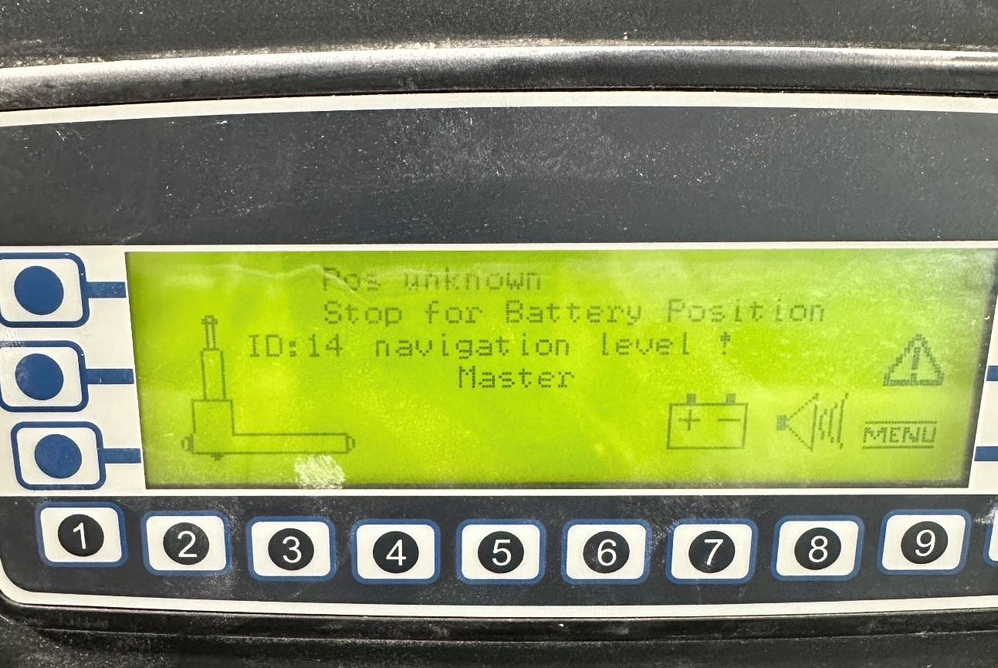
How To Fix:
This alarm occurs when the AGV loses communication with its top laser.
To resolve:
- Walk the AGV until it has a clear view of its reflectors.
- Restart the AGV using the automatic sequence:
  - Automatic Mode
  - Press the Blue button
  - Press the Green button
Additional Tips:
- If the issue persists, try cleaning the top laser and reflectors.
- You may also need to reboot the AGV.
.

